Mr. Sabado, Pre-Algebra Friday, October 25, 2013

Homework

Due Today:
-Quiz Review: Worksheet
- Test Corrections
- Homework Calendars

Due 10/28:
-Extra Credit

Quiz Today!!!

Agenda

- Warm-Up

- Homework Check
- Turn in Calendars
- Turn in Test Corrections

- Quiz: Inequalities and their Graphs

- Quiet Activity
- Return Graded Work

Warm-Up

Solve
- 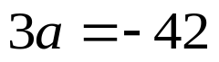

2) 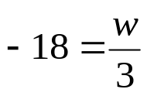


whs.saba.do

“It is never too late to be what you might have been.”
- G. Eliot

